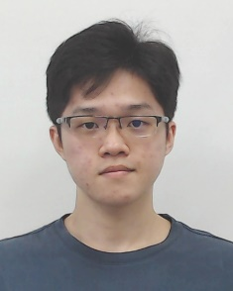**FOCS_StudF03: Student’s Progress Report**

Attached a photo here

(use digital photo)

**Tunku Abdul Rahman University College**

**Faculty of Computing and Information Technology**

**Industrial Training Progress Report**

Activity Log

|  |  |
| --- | --- |
| Name of Trainee: | Kong Mun Jun |
| Name of Company: | Ezee Technosys (M) Sdn Bhd |
| Month/Year: | April / 2022 |

|  |  |
| --- | --- |
| **Week** | **Projects / Activities** |
| **1** | Go through an assessment review about the knowledge of every system, so we could know the mistake and misunderstanding from the system and correctly know the system better.  Our supervisor Ga Ka, had conduct a training about Requirement study for hotelier to teach us what to ask and interview the hotelier to fetch the demands and requirement for the system from the hotelier |
| **2** | Handle a lot hotelier messages via Whatsapp and getting updates from ZOHO project platform to receive updated information of new hotel and assist them with configuring their owned system. Did some OTA mapping for various hotel as well. |
| **3** | The Company Director, Mr. Loke, conducted a personal development session with all the intern. He gave us some assessment such as personality test and play a game known as Lost at Sea. I have learn a lot from the session where I have more understand myself and capability, also learn to be a better person in working environment.  Mr. Loke also provide all intern a chance to organise a camping activities, all of us only given a short time to plan all the program and materials needed for the camp. During weekday, we also enjoy ourselves in the camping site with forestry and laughters. |
| **4** | I was given an opportunity to do some findings from a rare product from the company. In a few days, I did some findings and had a discussion with supervisor Ga Ka to report my findings towards the product.  Supervisor also had 2nd assessment for the interns to examine our further understanding towards the company and cases might happen from the hotelier.  Company had organize an event known as Play Learn Grow Together (PLGT), they held a competition called I am the Speaker. We interns needed to prepare a 18min talk about certain topics. Preparation are given 2 weeks time. |



**Suggestions / Comments / Additional information (if any):**

**Leave Application / Leave Taken**

1.From (dd/mm/yyyy)___ ___ to (dd/mm/yyyy) ___ ___ ( _ days)

2. Reasons for taking leave:

1. Total number of days taken:

**I hereby declare that the information given above is correct.**

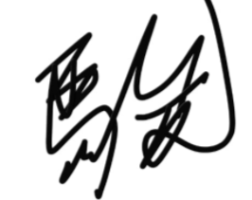

**Signature**: _____________________ **Date**: ___29/04/2021__

*(dd/mm/yyyy)*

|  |  |  |  |
| --- | --- | --- | --- |
| **Endorsement by the Company Supervisor:** | | | |
| **The above is a true record of activities taken by the trainee in the captioned week.** | | | |
| Signature of Supervisor: | __________________________ | | |
| Name of Supervisor: | __________________________ |  |  |
| Date: | *(dd/mm/yyyy)*_______________ |  |  |
| Email: | __________________________ |  |  |
| Mobile / Office Contact No.: | __________________________ |  |  |
| Company Stamp: | Company stamp with address |  |  |

